Visiativ Value Added Tutorial: How to Download and Begin a SOLIDWORKS Desktop Install.

In this tutorial we provide an overview of how to easily access your desktop SOLIDWORKS download media. This process applies to perpetual or term licenses of SOLIDWORKS Standard, Professional, or Premium.

Not sure which license type you have or need a hand with your installation? Contact our support on support@visiativ.co.uk or access our support services using the tools in the support quick link area of your dashboard.

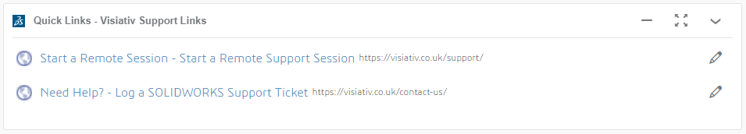

As part of your Visiativ added value subscription, we have provided you with easy access SOLIDWORKS download links as part of your Visiativ Solutions - SOLIDWORKS dashboard.

- You can access these on the ‘Support & Installation’ tab.

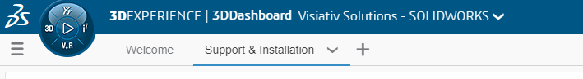

Don’t have access to this dashboard yet? Contact our support for assistance.

- You should see the links in the app at the bottom right of the dashboard.

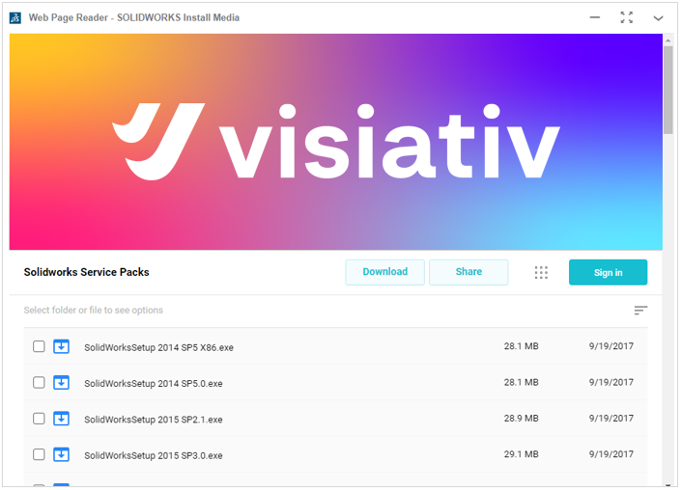
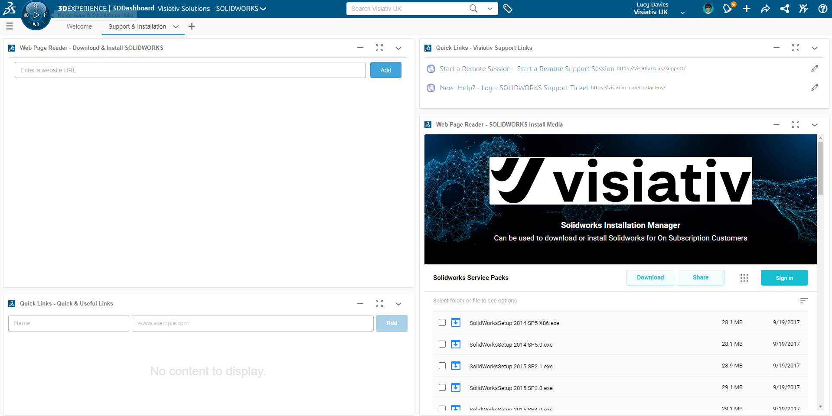

- Choose the version and service pack you require, right click, and hit Download.

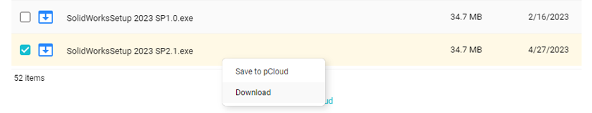

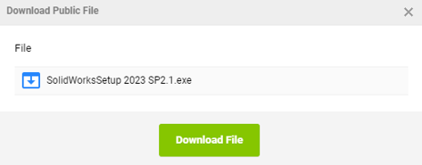

- A .zip file will download. This file is small in size and will manage the installation process for you.

- After the SolidWorksSeup.exe zip file has completely downloaded, run the SolidWorksSeup.exe file from your downloads folder.

- You can then Browse to the location where you want the files to unzip using the browse button on the WinZip dialog. Note: it is a good idea to put these somewhere local.

- Hit Unzip.

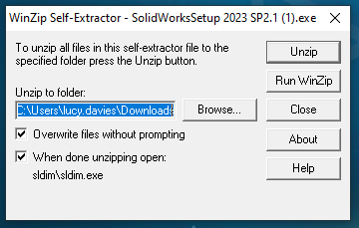

- After the files have extracted select OK and the SOLIDWORKS Installation Manager will start automatically.

- Here you can begin your SOLIDWORKS Desktop install.

