Visiativ Value Added Tutorial: How to add other users.

In this tutorial we provide an overview of how you can add other users to 3DEXPERIENCE if you have multiple licneses. The other users will then be able to access your Visiativ Solutions – SOLIDWORKS dashboard. This process is a Visiativ Value Added subscription benefit that will give you and your team easier and quicker access to SOLIDWORKS download media.

Not sure which license type you have or need a hand with your dashboard? Contact our support on support@visiativ.co.uk.

- Firstly, as an admin user, you will need to to activate the Platform Management Dashboard.

To choose the dashboard, click on the Dashboard List icon to the left of the compass.

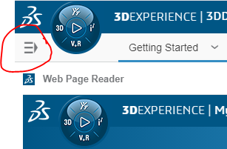

- From the Dashboard List, choose Platform Management dashboard. It will then highlight blue, and the name will get reflected in the top corner.

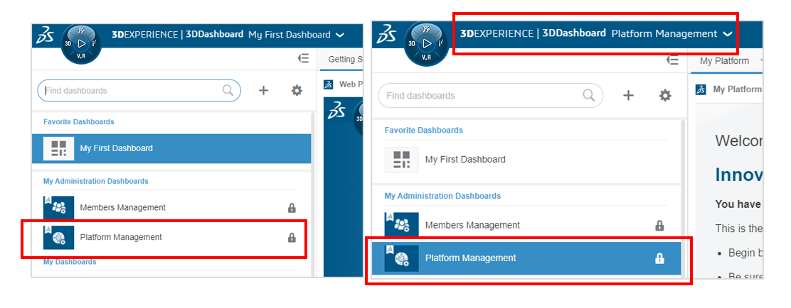

- In the dashboard, choose the Members tab. Then choose Invite Members. This will bring up the Invite Members Dialog.

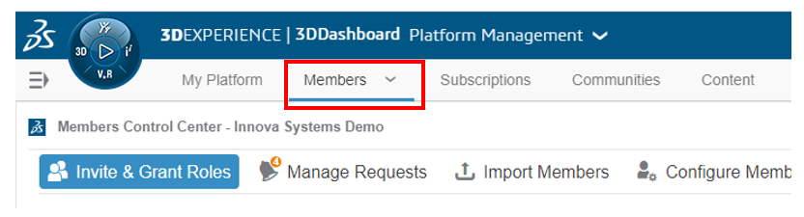

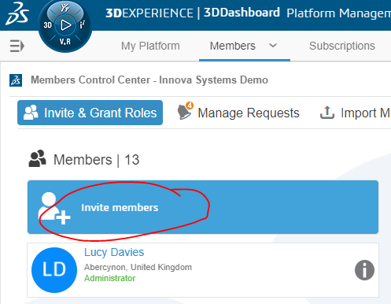

- The roles that you have available to you on your tenant, will be shown on the members tab below the Members section.

For a user to access the Visiativ Solutions – SOLIDWORKS dashboard, they will need a minimum of a 3DSwymer role.

- To add the user, you will first need to enter their email into the dialog as below. You must their choose their user rights - whether they are a standard member or an administrator. Administrator users are able to access the Platform Management area (think admin portal or license portal). Click Next.

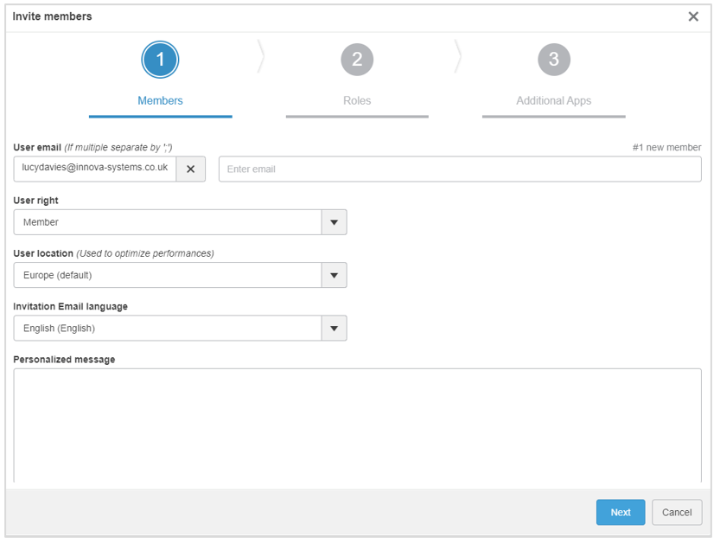

- On the next page, you will need to select their roles. By default, they will already be assigned a 3DSwymer role.

Assign other roles if required or available.

- When Invite is clicked, an email will be sent to that user’s email address. It will include a link that the user can click to access the correct location. This link will take them to the log in page to your tenant. It is recommended that they bookmark this location.

Once a user has been added, you are able to share the Visiativ Solutions – SOLIDWORKS dashboard with them.

